Application | URL | Testing Actions & Credentials
🛒 Customer PWA | http://localhost:3004 | Enter postcode WN1 1AA (or check collection), select menu options, complete checkout, and view the live order tracker.
📱 POS Terminal | http://localhost:3001 | Use PIN 1111 (Admin) or 3333 (Cashier) to unlock. Start a shift with float, browse/select items, customize modifiers, and submit orders.
🎛️ Kitchen Monitor (KDS) | http://localhost:3003 | Displays live kitchen cooking tickets. Check incoming tickets in real-time and click "START COOKING" or "BUMP" to update their statuses.
📊 Admin Backoffice | http://localhost:3002 | Log in with Username admin and Password Admin123!. Manage categories and products, customize pricing details, and review system statuses.

Mongodb Database user
Username: jahangirbaigm_db_user
Password: txIC4uhBCqeTrYa9
Usename: takeawaypos
password: C50jm1HLPx7qrS86
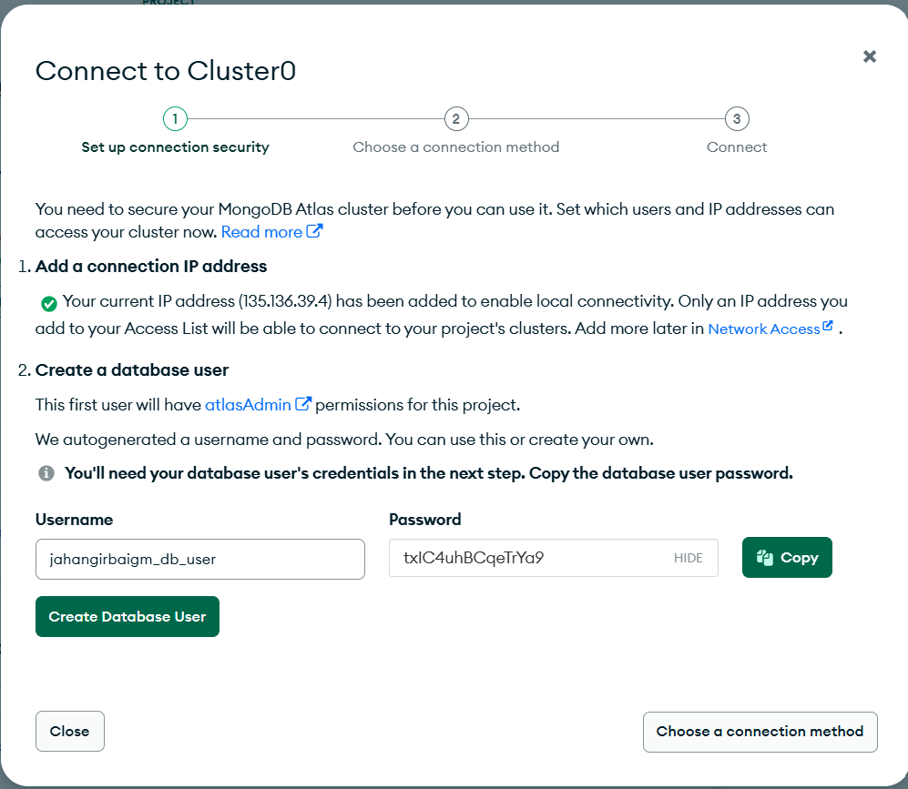

Following are the details of Menu as per my understanding.
Level 1 - CATEGORY --- example: CURRIES, STARTERS, PIZZAS, KEBABS, BIRYANI... etc.
Level 1.1-SUB -CATEGORY - example: under CURRIES sub catergories - BALTI DISHES, BHUNA DISHES, ROGHAN JOSH DISHES, KORMA DISHES..etc
NOTE: Not every CATEGORY will have SUB-CATEGORY
Level 2 - PRODUCT -- example: under BALTI DISHES - CHICKEN BALTI, MEAT BALTI, MINCE MEAT BALTI, PRAWN BALTI...etc
LEVEL - 3 -Then there are GROUPS which are groups of different dishes that we offer (example .. Extra Add Ons for curries, Curry choice for Pizzas, 8 Inch Pizza Toppings, Sauce and Salad for SFC (southern fried chicken), Add Ons for Chips ...etc).
- There GROUPS are assigned under PRODUCTS which are relevant to that PRODUCT like Add ons for Chips will be added under PRODUCT 'CHIPS' and 'Extra Add Ons for curries' will be added under ALL CURRIES .
-- GROUPS are the combination of LABEL and COMPONENT
for example - under the "EXTRA ADDONS FOR CURRIES" we will have LABEL "LESS, NO, ON CHIPS, ON BURGET, ALL OVER, ON HALF" and COMPONENTS - " POTATOES, SPINACH, MUSHROOMS, ONION". following is the screenshot of the same from the POS. check right side for the customer ORDER.
LEVEL -4 - COMPONENT - components are extra addons or variants to the product.
examples: FRSH TOMATOES, ONIONS, MUSHROOM, SWEETCORN, CHICK TIKKA, PEPPERONI, TUNA, CHEESE CRUST, BALTI SAUCE, SALT, GO REGULAR, GO LARGE, EXTRA GARLIC, NORMAL, HOT, MILD, WELL DONE.ON ONE.. etc ( I will share all the options later).
LEVEL -5 - LABEL - Labels refer to the quantity of add-ons (COMPONENTS).
example: LESS, NO, ON CHIPS, ON BURGET, ALL OVER, ON HALF.
Apart from above MENU options , we need to seperate cuisines (PRODUCTS) - DEPARTMENT - which will help the chefs to prepare different meals simultaneously, For example, a customer orders, 12 inch PEPPERONI PIZZA and CHICKEN BALTI, then two prints will be generated for preparation, i..e on receipt for PIZZA department ( which is usually at FRONT) and one for CHICKEN BALTI department (which is in BACK kitchen).
example for DEPARTMENT - PIZZA, STARTER, CURRYS, NANS, RICE, BURGERS, KEBAB, SIDE ORDER, DRINK N DESSETS.

